# PeopleSafe - Handling Compound Calls – Care

Compound Pharmacy to Fill for Members

Compound Prescription Already Filled

New Compound Prescription

Compounding Notification Letter Template

Related Documents

**Description:** Provides the Point of Sale and Paper Claims procedures when a member is asking about a new-compounded prescription, asking for a refill for compounding medications.

|  |
| --- |
| Compound Pharmacy to Fill for Members |

Icon - Important Information

* **Millers of Wyckoff no longer handles insurance company compound requests.**
* Mail Order pharmacies stopped filling compound prescriptions as of 03/01/2019.
* **Do not run** Test claims to determine compound prescription coverage since they require more than one ingredient, and the Test Claim functionality only allows pricing on a single ingredient. We are unable to provide pricing information to our members about compound medications.

Top of the Document

|  |
| --- |
| Compound Prescription Already Filled |

If you receive a call about a compound that has been filled and submitted under the new D.0 claim submission format, follow these steps:

|  |  |  |
| --- | --- | --- |
| **Step** | **Action** | |
| **1** | Determine if the compound prescription was processed through the member’s prescription plan.  **Notes:**   * The phrase “DO NOT USE” may display in place of a medication name. This may require a call to the pharmacy or reviewing the compound hyperlink as identified in Step 2. Standard drug names may not display. Ask the date of the file, and which pharmacy was used. * If the member intends to use [Claims Coordination of Benefits (COB) (004599)](https://thesource.cvshealth.com/nuxeo/thesource/#!/view?docid=7471cab3-a401-4828-8b07-838b4c8fdd55) to cover a compound medication, they must submit the claim via Paper Claim. | |
| **If…** | **Then…** |
| Yes | Proceed to Step 2. |
| No | Advise members that the pharmacy should submit the compound prescription electronically.   * If this is not an option, determine if the client allows Paper Claims. * A [Compound Prescriptions Paper Claim Form (065609)](https://thesource.cvshealth.com/nuxeo/thesource/" \l "!/view?docid=4551aa74-d56c-4466-89ae-1d2d4ffd9366) is needed, which can be ordered via Fulfillment RM Task. Refer to [Paper Claim Multi-Ingredient Compound Prescription (042384)](https://thesource.cvshealth.com/nuxeo/thesource/#!/view?docid=06a1b33b-4f4a-4603-a8ab-e0f1376bfdca). * If the plan allows, members can submit an online compound reimbursement claim on caremark.com. Refer to [Caremark.com – Submitting Paper Claims Through Desktop/Mobile Site or Mobile App (Commercial Clients) (021490)](https://thesource.cvshealth.com/nuxeo/thesource/#!/view?docid=54a38024-1554-4f79-b741-7a24347df7d3).      * Do not run Test claims to determine compound prescription coverage as they require more than one ingredient and test claim functionality only allows pricing on a single ingredient. * Review the CIF to ensure that CVS Caremark handles the plan’s paper claims. If not, provide the address in the CIF to the member for mailing.   **Note:** Members mail the compound paper claim forms as follows:  If a government plan:  Government Address:  <PBM Name>  P. O. Box 52195  Phoenix, AZ 85072-2195  If a commercial plan:  CVS/Caremark  P.O. Box 52136  Phoenix, AZ 85072-2136 |
| **2** | Access the **Prescription Details** screen for the Rx in question and locate the Compoundthen select the: **Yes** hyperlink.  **Note:** This hyperlink is available for compound prescriptions submitted under the new claim submission format and has a 12-digit prescription number.    **Result:** Compound Details screen displays. | |
| **3** | Review the **Status** of each ingredient and the **Ingredient Cost** (allowed cost).    **Note:** If a PBO was applied, it is displayed in the PBO field. Commercial clients may choose to allow OTC ingredients within compound claim to be covered. | |
| **If the Status is…** | **Then…** |
| Accepted | The ingredient is covered, and the ingredient cost indicates the amount reimbursable to the pharmacy (allowed cost). |
| Denied | The ingredients are not covered, and the Ingredient Cost is displayed as $0.00.   * The cost of that ingredient will not be factored into the member’s copay, and it will be at the discretion of the pharmacy whether to charge the member the out-of-pocket cost for the non-covered ingredient.   + If the pharmacy needs assistance in bypassing non-covered ingredients, direct them to the **Pharmacy Help Desk**. * To **view the settlement codes** explaining the rejection, click the hyperlink on the Denied status field. |
| **4** | Access the **View Financials** or **View Client Financials** screen then explain the member’s copay based on the information within the screen and the Accepted/Denied status within the previous Compound Details screen.  **Note:** Although each ingredient is adjudicated separately, they are added together to calculate the member’s copay.  **Example:** If a compound contains three (3) ingredients, each approved at $10 dollars, the total ingredient cost would be $30. A member with a flat copay of $5 would only be charged $5 copay. A member with a percentage copay of 20% would be charged $6.  **Note:** The pharmacy may include a **Level of Effort Fee** along with the ingredient costs and other charges. The Level of Effort is determined by the complexity of decision-making or resources utilized by a pharmacist to perform a professional service. This fee is factored into the total cost the pharmacy submits for reimbursement.    **Example from RxClaim View Financials Screen** | |

Top of the Document

|  |
| --- |
| New Compound Prescription |

If you receive a call about determining coverage for a new compound prescription, follow these steps:

|  |  |
| --- | --- |
| **Step** | **Action** |
| **1** | Review the **CIF** and **Plan Summary** to determine if the compounds in general are covered and then advise the member accordingly. |
| **2** | Advise the member to contact their retail pharmacy to determine if they will be able to make the compound then proceed to the next step.  **Note:** If the member intends to use a Coordination of Benefits to cover a compound medication, they must submit the claim via a Paper Claim.  For additional information, refer to [Claims Coordination of Benefits (COB) (004599)](https://thesource.cvshealth.com/nuxeo/thesource/#!/view?docid=7471cab3-a401-4828-8b07-838b4c8fdd55) and [Paper Claim Multi Ingredient/Compound Prescription (042384)](https://thesource.cvshealth.com/nuxeo/thesource/#!/view?docid=06a1b33b-4f4a-4603-a8ab-e0f1376bfdca). |
| **3** | Inform the member that the price of the compound will be available once it is submitted through their insurance. Due to the complexity of compounds, it is not possible to provide an accurate price quote in advance.  Icon - Important Information Encourage the member to ask the pharmacy to submit the claim to their insurance first before creating the compound; this gives them the opportunity to decline if unwilling to pay for the cost of the compound. |

Top of the Document

|  |
| --- |
| Compounding Notification Letter Template |

The following [letter template](https://www1.caremark.com/psafe/csv/document/cms-pdm-1114792.pdf) is used for notifying members that they can obtain their compound prescription through another compounding pharmacy.

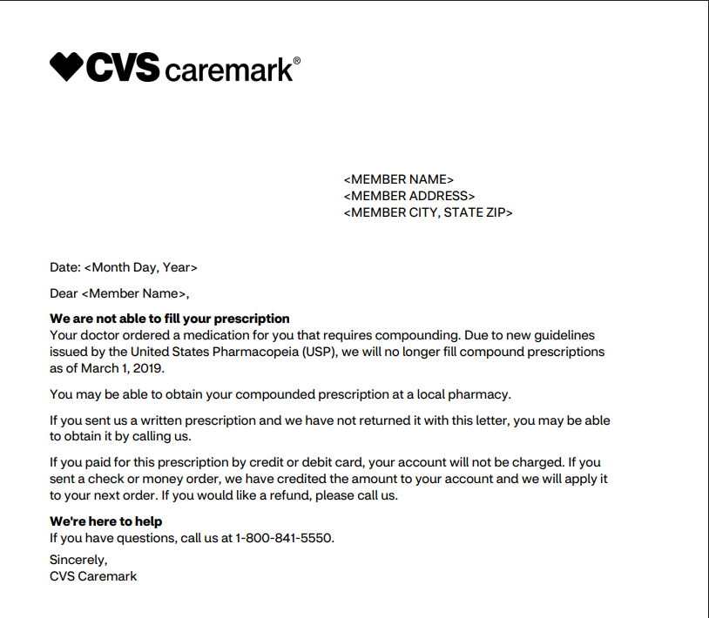

Top of the Document

|  |
| --- |
| Related Documents |

**Parent Document:** [CALL 0049 Customer Care Internal and External Call Handling](https://policy.corp.cvscaremark.com/pnp/faces/DocRenderer?documentId=CALL-0049)

[Customer Care Abbreviations, Definitions, and Terms Index (017428)](https://thesource.cvshealth.com/nuxeo/thesource/#!/view?docid=c1f1028b-e42c-4b4f-a4cf-cc0b42c91606)

[Log Activity/Capture Activity Codes (005164)](https://thesource.cvshealth.com/nuxeo/thesource/#!/view?docid=bdac0c67-5fee-47ba-a3aa-aab84900cf78)

Top of the Document

Not to Be Reproduced or Disclosed to Others without Prior Written Approval

**ELECTRONIC DATA = OFFICIAL VERSION – PAPER COPY – INFORMATIONAL ONLY**